NON-CONFIDENTIAL
APPLICATION FOR INVESTMENT

Before submitting an investment opportunity to MABA, please review our Investment Criteria document on the MABA website (https://bioangels.net/investment-criteria/) and the “Please note the following” section below to ensure a fit.
Application checklist. Please submit the following:
- This application (in PDF format, with the name of your company incorporated into the document name)
- Pitch deck
- An executive summary (which should not exceed three pages)
- Any relevant publications and data
Please make sure that this application contains only non-confidential information.
MABA members include both individuals, as well as corporations. Please do not provide any information you would not want seen by such entities.
Please let us know if you have any questions or concerns about these requirements.
By submitting an application, you acknowledge your acceptance of the items noted above.
If your company is selected by the Screening Committee to present, we will send you an invitation to present to the group. Companies will be scheduled to present on a first-come, first-serve basis.
We look forward to receiving your application.

Please note the following:
1. Direct-to-consumer (DTC) and over-the-counter (OTC) products can be challenging for investors for several reasons, including their funding requirements. If you are submitting an application for DTC or OTC company, please make sure you articulate how the investors will realize a return. Also, if your product or service requires DTC or is direct-to-patient, please be sure to provide detailed budget assumptions by year and strong rationale/support for size and timing of exit and have someone on your team with demonstrated DTC experience in the target area. MABA also rarely considers investing in apps and service-based offerings.

2. If your company has applied to MABA in the past, please address all previous concerns noted by MABA.
3. For US companies, please note that MABA will only consider investing in C Corps.

4. MABA would likely not consider an investment in a convertible note unless the note includes a valuation cap and/or a discount to the next priced round. MABA prefers not to invest in SAFEs.

5. Some startups may be able to reach an exit by raising less than ~$25 million, achievable in multiple syndicated angel rounds and on “angel-friendly” terms, whereas other startups may require large venture capital (VC) rounds in the future to reach an exit. Such large VC rounds, often accompanied by liquidation and other preferences, can be significantly dilutive and detrimental to earlier investors such as MABA (see our blog post here: (https://bioangels.net/blog/is-angel-capital-or-venture-capital-right-for-your-company/). If you believe that you will be required to raise money from VCs prior to exit, please provide information in your application regarding steps you will take to protect the interests of prior investors. Examples might include, but should not be limited to, most favored nation provisions, participating preferred liquidation preferences or full-ratchet/weighted average anti-dilution protections.

6. While MABA appreciates that early-stage companies may not always have a complete team in place, it is our expectation that the person currently in charge of setting strategy and direction understands and can articulate a clear path to exit, preferably by acquisition, and outline the team that will be put in place to help reach that exit. Additionally, by the time the MABA investment takes place, a five or six-person board of directors should or will need to be in place, with a majority of members being independent (outsiders).

While the above are not hard and fast rules, they are generally behind the majority of the rejections issued by MABA. Other common reasons for rejections include:
- High employee salaries, especially in relation to the size of the round
- Insufficiently experienced team
- Too early (for example, insufficient data to support the business case or scientific hypothesis)
- Too high a valuation for the stage of the opportunity or size of market
- Too small a market
MABA is grateful for the support of our sponsors:
Please let us know if any of them can assist you on your journey. We will be happy to make an introduction.

AcademicLabs.com is the first user-friendly and comprehensive interface for biotech startups, pharmaceutical companies and scientific experts to collaborate, consult, monitor, license a technology, sell, or recruit.

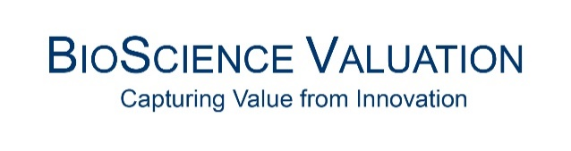
Bioscience Valuation BSV GmbH is a globally operating premier life sciences valuation company helping healthcare sector clients improve the value proposition of their investments and minimize risks to enable well-informed decision-making.

Courage Growth Partners offers leadership development for high-potential leaders to optimize growth with game-changing innovations and transformations.

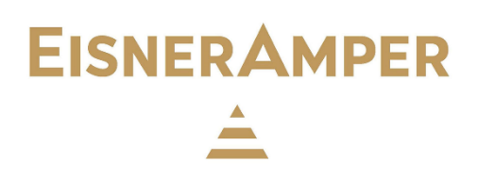
EisnerAmper, one of the largest business consulting firms in the world, is comprised of EisnerAmper LLP, a licensed independent CPA firm that provides client attest services, and Eisner Advisory Group LLC, an alternative practice structure that provides business advisory and non-attest services.

kmacconnect is a boutique PR firm that helps companies and people engage purposefully, seeking innovative ways to amplify clients’ value propositions, create strategic synergies, and build relationships.

As a global leader in innovative and comprehensive laboratory services, Labcorp (NYSE: LH) provides unparalleled diagnostics and drug development laboratory capabilities.
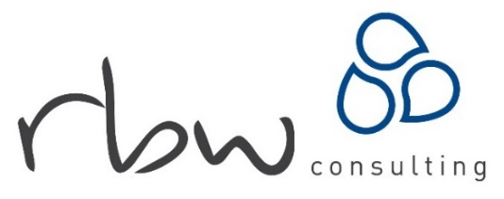
RBW Consulting is a B Corp certified life sciences recruitment & search consultancy helping life sciences businesses change the world by giving them the people, insight & networks to innovate and scale.

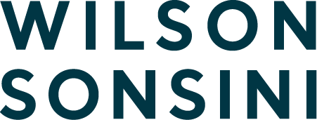
Wilson Sonsini Goodrich & Rosati is the premier legal advisor to technology, life sciences, and other growth enterprises worldwide. They represent companies from startups to global corporations, as well as the VC/PE firms, and investment banks that finance and advise them.

- Name of company (plus website – if any)
- Name of main contact (name, title, phone(s) & email)
- Location of company (if virtual, location of main contact)
INTRODUCTION
- What is the problem your company is trying to solve?
- Please describe your company’s solution to the problem, above, in plain English.
- Company start-up date
FUNDING
- Describe non-dilutive or grant funding already received or applied for (please differentiate between received and applied for)
- Amount of money previously raised (total)
- Date last round closed
- Post-money valuation at the last round
- Current round: Amount of money being raised
- Current round: Deal Terms (note/priced, discounts & caps, pre-money valuation)
- Date current round began & amount of money committed/invested so far (differentiate between soft and hard commitments)
- Investors already committed to participating in this round
- Minimum and Maximum $ amount available for MABA to invest in this round
- Use of Funds from this round, including breakdown of amounts for major items
- Future Financing: Excluding the current round, how much more investment capital will be required to reach an exit (including all future rounds only, excluding grants or other non-dilutive funding)?
- Where will your future funding (after this round) come from? Please include both dilutive and non-dilutive sources.
- What event will render further funding unnecessary (e.g., acquisition, licensing deal, breakeven achieved, other) – and time to reach that event?
- Exit: What will an expected exit look like (type, timing, comps, ROI)?
PRODUCT
- Is this a single product/service or a platform?
- If the company has developed a platform, what is the first product/service to be marketed commercially?
- Please provide a non-confidential description of how your product works
- Please provide data in support of the product’s efficacy
- Please indicate at least one significant publication that you believe supports your technology. (Be specific. If possible, please attach to submission)
- Are there toxicity or other issues associated with your product?
- Please list the reasons your product is superior to the standard of care, and to competitors’ products (including those pending approval)
- Current development stage (of first product/service)
- Briefly describe how product/device will be manufactured
MARKET
- Total addressable market (if platform – for first product only)
- Please identify all your known competitors
- In addition to patients, please identify all entities (doctors, hospitals, insurance companies, etc.) that would benefit from your product – financially and otherwise, please indicate how they would benefit, and their reasons to support the product’s adoption
- Sales and Go-to-Market Strategy
- If already selling – annual $ sales, recent growth rate and number of customers
- Please identify current & anticipated alliance partners (please be specific)
INTELLECTUAL PROPERTY (IP)
- Describe the status and scope of patent protection, if any (number of applications, nature of claims, when filed/granted)
- Is there other IP – that might affect the product/service?
- Who owns the patents and other IP, if any?
- Describe the competitive IP landscape and how the company’s IP fits within that landscape
REGULATORY & REIMBURSEMENT
- FDA strategy, time to approval of primary indication/first product, and approval pathway
- Reimbursement strategy (one sentence)
TEAM
- Management team (P&L/operating experience, significant accomplishments, prior fundraising experience and return to investors (If any))
- Endorsement(s)/key supporters/key opinion leaders (specific names)
- Professional advisors (specific names) and their area of expertise (legal, accounting, regulatory consultants, others?)
- Describe all special deals and circumstances with and between partners, related parties and anyone else (grant backs to founders, special licenses, etc.)
- Current salary and other compensation for each executive. How/will it change after financing?
- Is the team complete? What functions / capabilities are needed, and when will they be added? Have people already been identified for these positions?
- Are any of the team members related to one another (if so, how)?
- Board of Directors: 1. How many are on the BOD now? 2. Of those, how many are Not insiders (founders/management) but Outsiders? 3. Of the Outsiders, how are they chosen, by whom? 4. How many are Independents? 5. How many elected by shareholders? 6. Please name each director, their job title & employer, and list (just a few) keywords describing their expertise and experience that is relevant to the company at this stage of its development. How/will this change after this funding round?
MISCELLANEOUS
- How can investors lose their money? What are the biggest risks (competitive, regulatory, technical, etc.) standing between the company and successful commercialization and exit?
- How did you hear of MABA?
- If you have a short video (<5min) that you would like to share, please provide the link here.
- If you have applied to MABA in the past and were rejected, please list the reasons given for your rejection, and why these no longer apply.

Please return this completed document – in PDF format and with your company name incorporated into the document name, along with an executive summary, pitch deck, and other relevant documents, to: info@bioangels.net. Please make sure that your company name is in the subject line.

Thank you.
Mid Atlantic Bio Angels (MABA)

